**Project 2:**

**Fadding Of LED(Light emitting diode)**

**Description**: In this project, we will know how a led fadding from LOW to HIGH and HIGH to LOW. For this project we need to know about PWM(pulse width modulation). Pulse Width Modulation, or PWM, is a technique for getting analog results with digital means. Arduino's PWM frequency at about 500Hz, the green lines would measure 2 milliseconds each. A call to analogWrite() is on a scale of 0 - 255, such that analogWrite(255) requests a 100% duty cycle (always on), and analogWrite(127) is a 50% duty cycle (on half the time) for example.

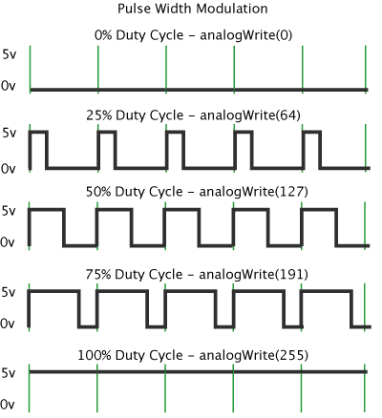

**Required Hardware:**

· Arduino Uno.

· Breadboard.

· Jumper wire.

· LED

· Resistor.

· USB type A/B.

**LED**:

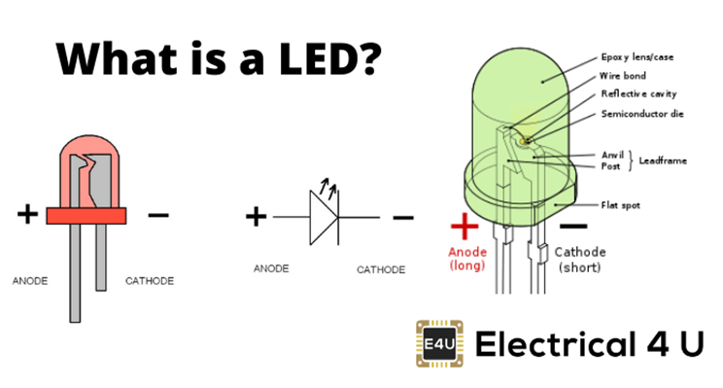

**PIN OF LED:**

LED refers to Light Emitting Diode include two pins:

1. Cathode(-) pin- must be connected to GND (0V)

2. Anode(+) pin - is used to control LEDs state

**Specifications:**

1. 5mm Round Standard Directory

2. Forward current: 30mA

3. Forward Voltage: 1.8V - 2.4V

4. Reverse Voltage: 5V

5. Operating Temperature: -30 to 85 degree celsius

**Circuit Diagram:**

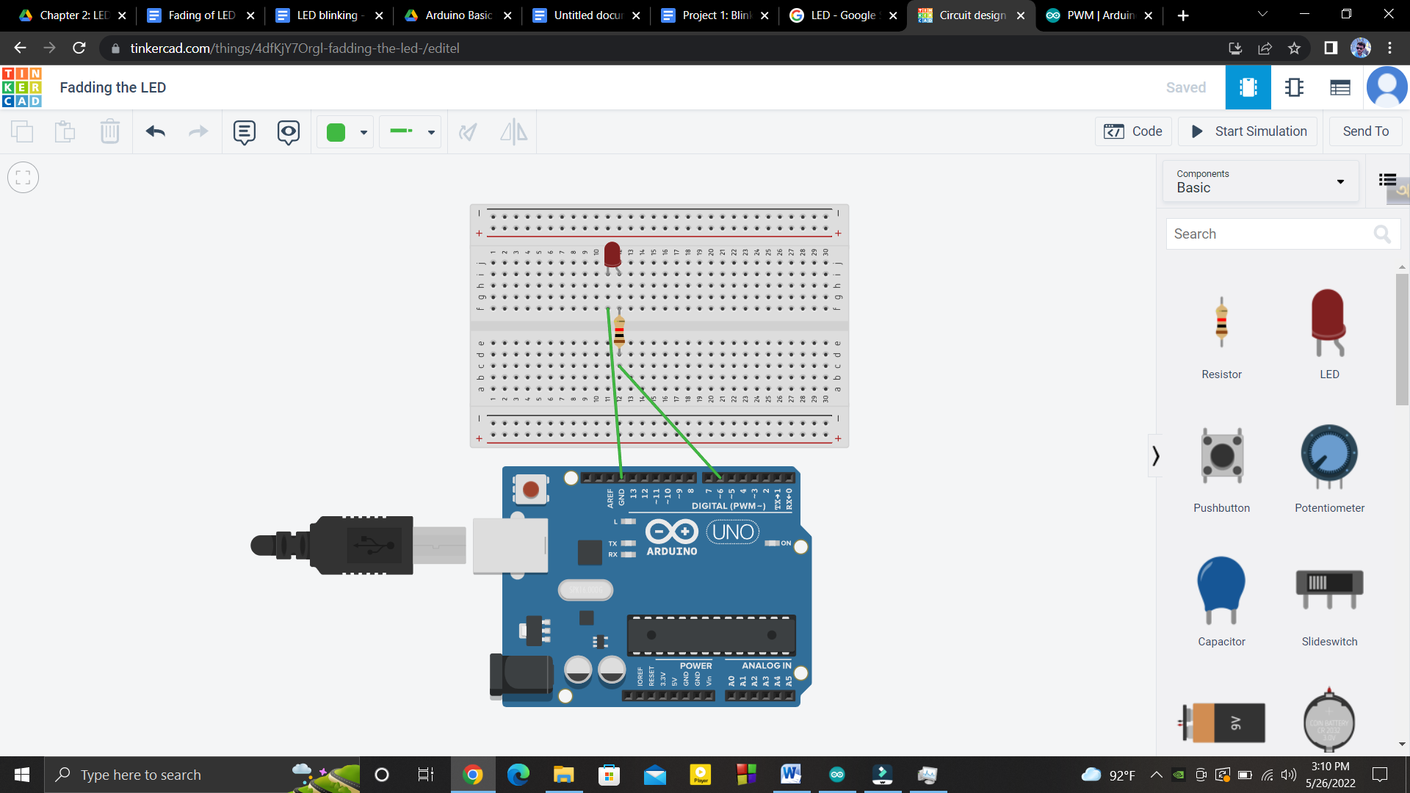

**Arduino and LED Connection:**

* LED cathode(-) pin to GND
* LED anode(+) pin to 330 ohm resistor to digital pin 6.

**Code:**

|  |
| --- |
| int pin1=6; int i;   void setup() {   pinMode(pin1, OUTPUT); }   void loop() {                             // fading of led from minimum to maximum   for(i=0;i<255;i+=5)   {   analogWrite(pin1,i);  delay(30);   }                               // fading of led from maximum to minimum   for(i=255;i>0;i-=5)   {   analogWrite(pin1,i);  delay(30);   } } |